Task 1.2p – Grady Ramsay 218257386

1. **Write what is responsive web design and why it’s important?**

Responsive web design is an approach to apply display adaptability to websites which is important as it allows seamless user experience and better accessibility to websites regardless of devices and screen size constraints.

1. **Write how to implement responsive web design with CSS and implement code; hint: CSS @media Rule.**

To implement responsive web design with CSS we can use the @media rule which allows for us to apply specific constraints based of screen size.

Below I’ve provided an example of an article that will remain centered with a width of 550px, If the device has a screen size lower then 575px the rule won’t apply causing it to fill the width of the screen.

An example of HTML and CSS:

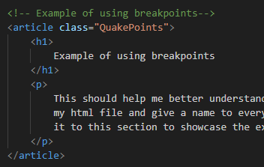 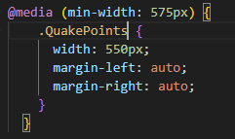

1. **Write a JavaScript file with at least 5 string methods. Hint: Use console.log function for output. (No need to include HTML and CSS).**

Here is a screenshot of the results of 5 string methods. You can check the JavaScript.js file for the code string methods used.

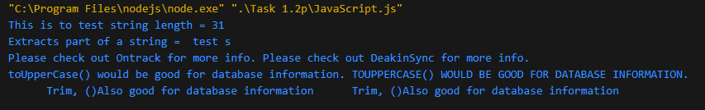

1. **Write a JavaScript file with at least 2 array variables (one string array and one number array) with total 5 array methods (you can use either string array or number array, or you can use both e.g., 2 methods using string array then 3 methods using number array). Hint: Use console.log function for output. (No need to include HTML and CSS).**

Here is a screenshot of at least 5 array methods using both a string and a number array. You can check the JavaScript2.js file for the code and methods used.

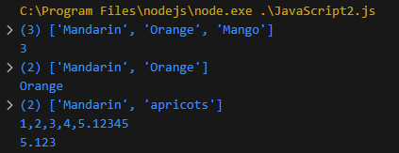

1. **Write a JavaScript file with at least 5 Date methods. Hint: Use console.log function for output. (No need to include HTML and CSS).**

Here is a screenshot of at least 5 date methdos in console. You can check the JavaScript3.js file for the code and methods used.

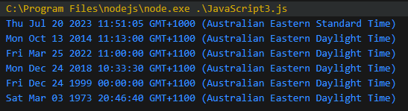

1. **Write your reflections on the above tasks. (Max 150 words)**

As there were no specifics regarding a reflection of max 150 words. I believe I didn’t have any issue whilst learning mor about CSS and JS.

I was able to successfully use JS to complete the task above, though I still think there is room for improvement when it comes to implementing JS into HTML which I’m sure we’ll get taught over the next coming weeks.

I still think there is much more to learn then these simple methods when it comes to JS and I look forward to learning it.

Link to GitHub repo: <https://github.com/Gradox9/SIT120Task1Grady>

Link to Demo video: <https://video.deakin.edu.au/media/t/1_3ti5a9b9>